Trolley Tours available on the Green Line
(Subway Surface) from Philadelphia’s City Hall
(For more information visit www.darbyhistory.com)
(All routes)
30th Street Station/Cira Center
University of Pennsylvania/University City/Drexel University
Birthplace of Eniac-worlds first computer
Home of Claes Oldenburg’s “button”
Irvine Auditorium (a building you have to see to believe)

Woodlands http://en.wikipedia.org/wiki/The_Woodlands_Cemetery
Routes 11, 13 and 36 Stop at the 40th Street Portal in front of The Woodlands and The Woodlands Cemetery entrance.
The Woodlands, a National Historic Landmark, began as a 300 acre property inherited in 1766 by William Hamilton (1745-1813) from holdings of his grandfather and father, both named Andrew Hamilton and prominent in Philadelphia law, politics, and business. William built a Georgian residence on the land in 1770 and used his landscape to increase America’s plant species. After the Revolution he doubled the size of his home and added a carriage house and stable to create one of America’s earliest neoclassical complexes designed in the English Robert Adam style. He patterned his landscape after English gardens and featured over 10,000 different plantings, many propagated in his own greenhouses. The Woodlands Cemetery Company of Philadelphia purchased the last of Hamilton’s estate in 1840 to preserve the landscape and buildings and convert 92 acres into what has become Philadelphia’s second earliest rural cemetery. Woodlands Cemetery remains active and features a 19th-century arboretum of over 1,000 trees on 54 acres. Beautiful Victorian cemetery monuments and mausoleums mark the graves of prominent Philadelphians and citizens and veterans of the region. Rembrandt Peale, Francis Drexel, Thomas Eakins, Paul Philippe Cret, Dr. Samuel Gross, Admiral David Porter, all rest at The Woodlands. www.woodlandsphila.org.

Rt. 11
Began as a horse car line in 1858 and still runs over original route down Woodland Avenue to Darby with access to University of Pennsylvania, Woodlands, Philadelphia College of the Sciences and Drexel University.
2 reputed birthplaces of William Claude Dunkenfield (W.C. Fields)
Site of J.G. Brill…maker of the Cadillac of trolley cars

St. James, Kingsessing, (1762) The second Swedish congregation in Philadelphia. Behind is the house used by General Howe during the 1777 siege of Ft. Mifflin, “the battle that saved America.”

Blue Bell Inn on Cobbs Creek 1766 /1747 (Colonial tavern on main stagecoach road between Philadelphia and southern colonies, scene of a battle during Revolutionary War. Astride “Minquas Indian Trail”, Rochambeau Revolutionary Route, and interim East Coast Greenway. Part of Philadelphia’s Fairmount Park)

Site of Printz’s (Old Swedes) Mill Pennsylvania’s first water powered grist mill built by Swedish Governor Johann Printz circa 1645

Darby (www.darbyhistory.com)
Darby Library (America’s oldest “public” library, established 1743)
Darby Fire Company No. 1 (One of America’s oldest volunteer fire companies , chartered 1775 and home to the Darby Ram and Shiffler)
Darby Friends Meeting (established 1682)
Darby Friends Burial Ground (started 1682)
Old Borough Hall (Planned Aboveground/Underground Railroad Museum

(1/2 mile walk up hill from Darby)
Eden Cemetery, America’s oldest African-American cemetery, birthplace of John Bartram and resting place of Marion Anderson, William Still and Octavius Catto

Rt. 13
Clark Park (site of Satterlee General Army Hospital….location of a statute of Charles Dickens and “Little Nell” said to be the only statue of Dickens on public display anywhere)
University City with an outstanding collection of beautiful Victorian buildings and homes
Mt Moriah Cemetery, part of the Rural Cemetery Movement and interim resting place of Betsy Ross.
Graceland Cemetery, Yeadon. Resting place of some 1.500 Civil War Soldiers, likely Black soldiers from nearly Summit Army Hospital
Cobbs Creek Park (Philadelphia’s green belt and a wonderful place to experience nature)
Site of Hilldale Park, home of the 1925 Negro Baseball League World Champion Darby Hilldales (6 of whom are in the Baseball Hall of Fame)
(Some of the No. 13 cars go on to Darby. See Rt. 11

Rt. 36

Bartram’s Garden http://www.bartramsgarden.org/information/
(America’s first botanical garden and home to famed naturalists John Bartram and son William Bartram….plant sales, tours of historic house and much more….boats connect with the Fairmount Waterworks along the Schuylkill)

John Heinz National Wildlife Refuge at Tinicum (requires a 4 block walk) http://www.fws.gov/northeast/heinz/
(Pennsylvania's largest freshwater tidal marsh, open daily free of charge with canoeing, birdwatching and nature walks to refresh the soul.

The West Philadelphia Passenger Railway Company was chartered April 28, 1857 and was the second street railway to be chartered in Philadelphia. Streetcars drawn by horses first came to Darby on 24 December, 1858. Today’s SEPTA Rt. 11 follows the same route through 350 years of history

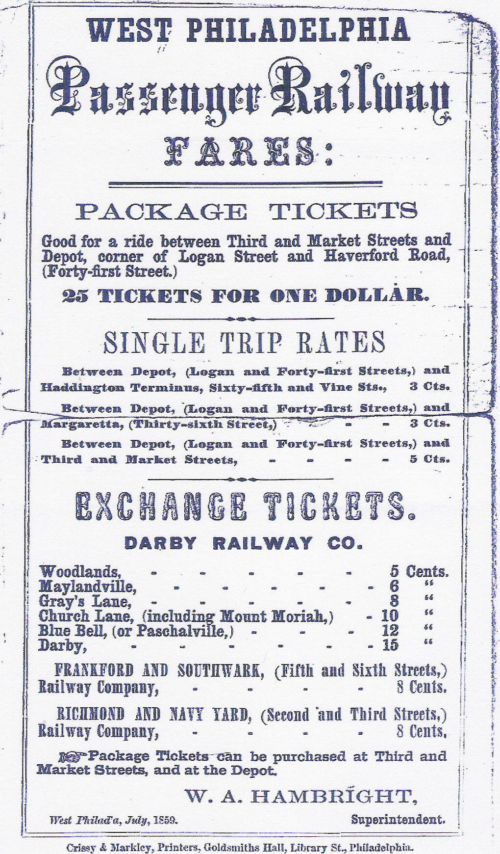
Schedule from the collection of Ed Springer

Trolley Tours
From Philadelphia’s City Hall
By Public Transportation

