Friends of the Blue Bell, Inc
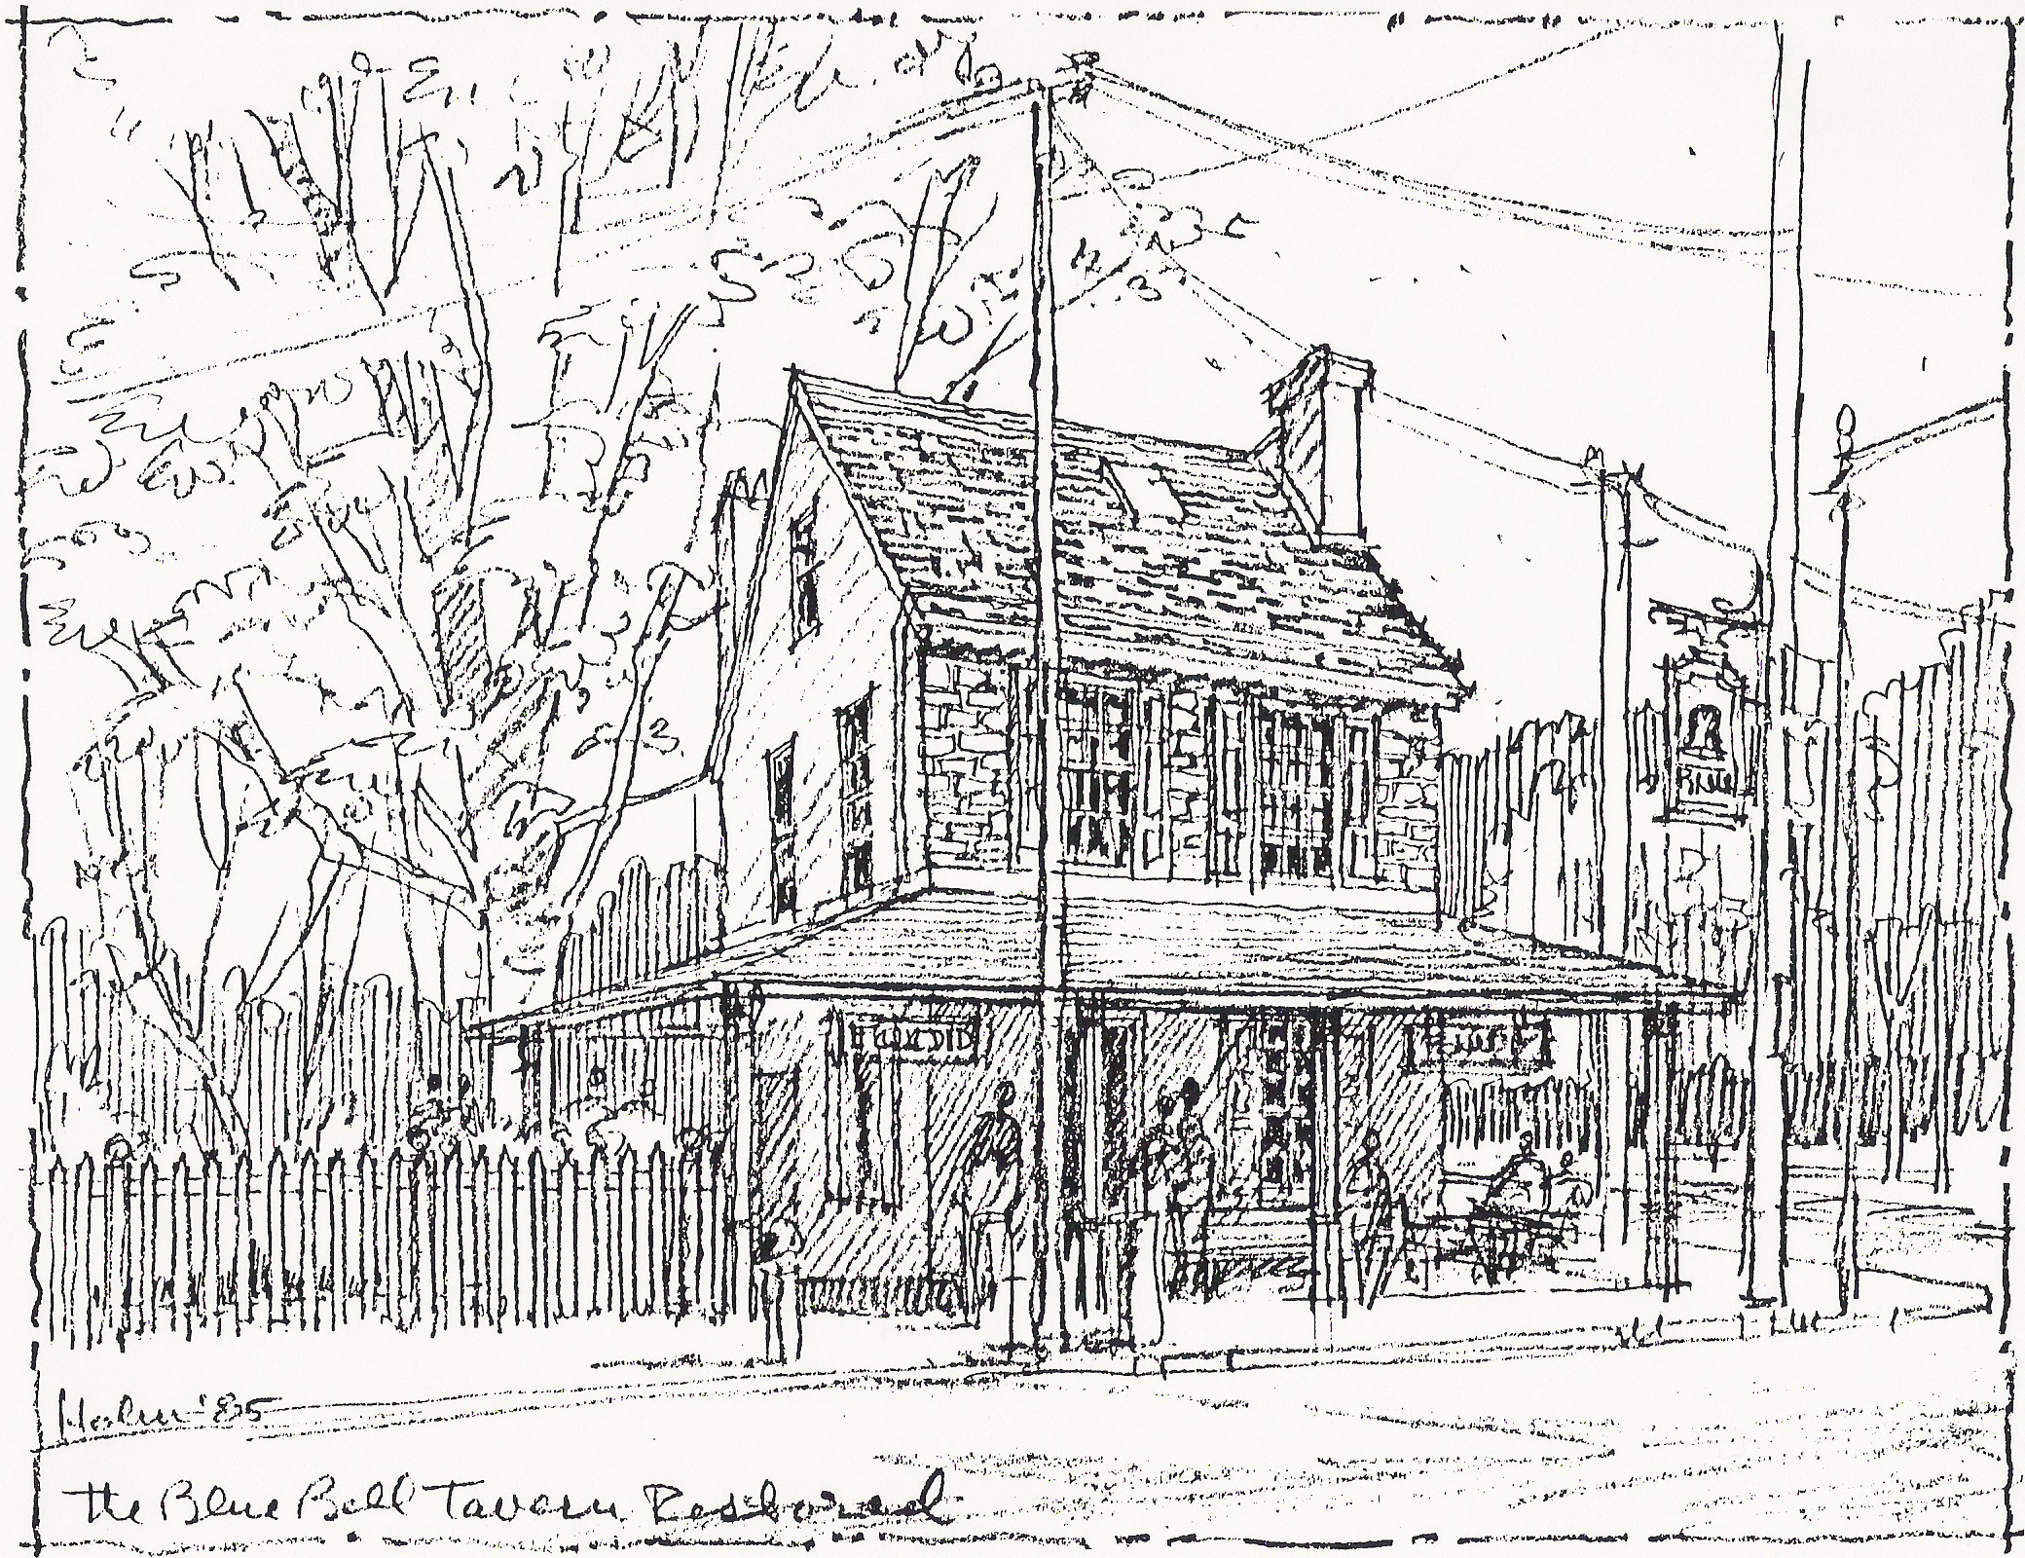
1006 Main Street
Darby, PA 19023
(610) 583-0788
www.DarbyHistory.com
The Ring of the Bell…
A Newsletter of the Friends of the Blue Bell, December 2013

Dear Friends:

The Friends of the Blue Bell was chartered in 1985 to “lease, restore, utilize, preserve and maintain the historic Blue Bell Inn and surrounding area for the educational and cultural enrichment of the Delaware Valley" and received an IRS 501(c)(3) designation in 1986. With the help of many wonderful people, the Bell was kept alive. After Hurricane Floyd in 1999 left five feet of water on the first floor, we became the Friends of the outside of the Blue Bell and have expanded our focus to other neglected area structures, widening the Ring of the Bell. We believe principles of Asset-Based Community Development, utilizing assets we already have, can help the area's economic development through heritage tourism and pride of place. These are some of our accomplishments and ongoing projects. We hope you will be inspired to join us!

In 2008, the Friends of the Blue Bell was able to coordinate efforts to get a historical marker commemorating Governor Printz’s (Old Swedes) Mill (c 1645) mext to the Bell which is believed to be Pennsylvania’s first water-powered mill and birthplace of Pennsylvania industry. The marker was unveiled as part of that year’s OcTrolleyFest, celebrating the first streetcar line from Philadelphia to Delaware County that came as a horse-drawn line to Darby in 1858 and which is still running as the SEPTA Rt. 11 Subway-Surface (Green Line). www.octrolleyfest.org

Old Borough Hall, 44 N. 9th Street, Darby, was built circa 1840 and has been a school, jail, police station, Borough offices, then was vacant for a number of years. In 2003 in celebration of the 150th anniversary of Darby‘s Incorporation, Old Borough Hall was cleaned, the wonderful pressed tin ceiling was revealed, and the building opened for visitors. The Friends of the Blue Bell entered into a lease with Darby Borough to use the building for a museum, celebrating Darby’s transportation heritage and Darby’s role in the abolition of slavery. The Friends of the Blue Bell is the sponsoring organization for the Friends of Old Borough Hall and has been able to deal with a severe leak on the southern facing roof on an interim basis. The “Raise the Roof” campaign continues. "We Have More Fun in Darby" T-Shirts are for sale and make great gifts.

Academy of Building Conservation (ABC) is an initiative that began in March, 2012 as part of Illuminating Darby to use our wealth of old buildings needing care and attention to train people in traditional building skills to be able to extend the useful life of older buildings and enhance vocational opportunities. Our first project is 1000 Main Street, a circa 1852 frame building in rough shape but with “good bones“ which we currently lease and are looking to restore as a "green" demonstration project. Contact us for a tour.

Your help would be welcome…We are actively seeking people interested in teaching or learning traditional arts or building skills, being a docent at the Museum. or helping in some other way…..Please call, or visit us on the web at www.academyofbuildingconservation.org , www.1000mainheritagearts.org or www.DarbyHistory.com We'd love to give you a tour and talk about ways you can help.

We Wish you a Wonderful Holiday Season and a Bright New Year Ahead!
Sincerely,
Jan Haigis, President, Friends of the Blue Bell
John Haigis, Secretary and Project Director, Friends of the Blue Bell

