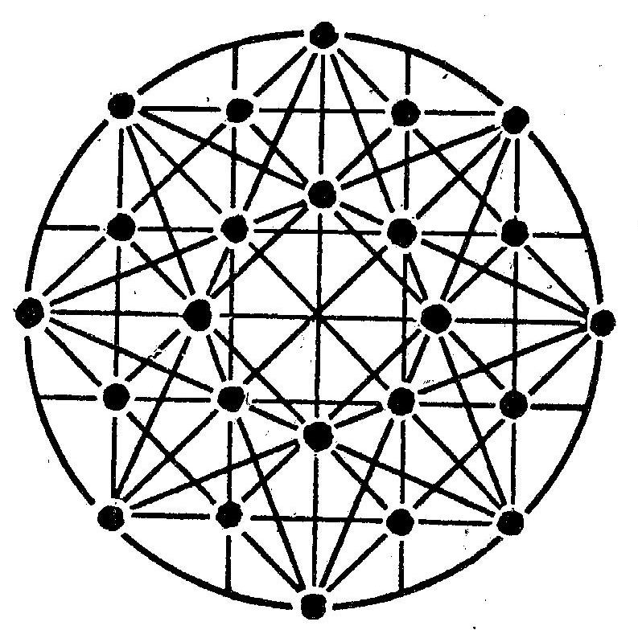
Darby 20/20, Seeking a new vision for Darby

As you know, Darby has many challenges but also many assets including unique history and strategic location. Darby is 10,000 people in one square mile, and if we can ever unite behind a common vision, there is virtually nothing we can't do or be. With this in mind, we are inviting you to be part of Darby 20/20, to help develop a vision of where Darby wants to be, and can be, six years from now in the year 2020. Please help find that vision by answering these three questions.

Three things I like about Darby are

________________________________________

________________________________________

________________________________________

By the year 2020 I would like Darby to have or be

_______________________________________

_______________________________________

_______________________________________

To make this happen I am willing to

_______________________________________

_______________________________________

_______________________________________

If you need additional space, please use the back. Thank you for your input. Questions? (610) 583-0788

Name/e-mail or phone: (optional) __________________________________________________

For more information visit www.DarbyHistory.com

