Existing Right of Way
Arial View
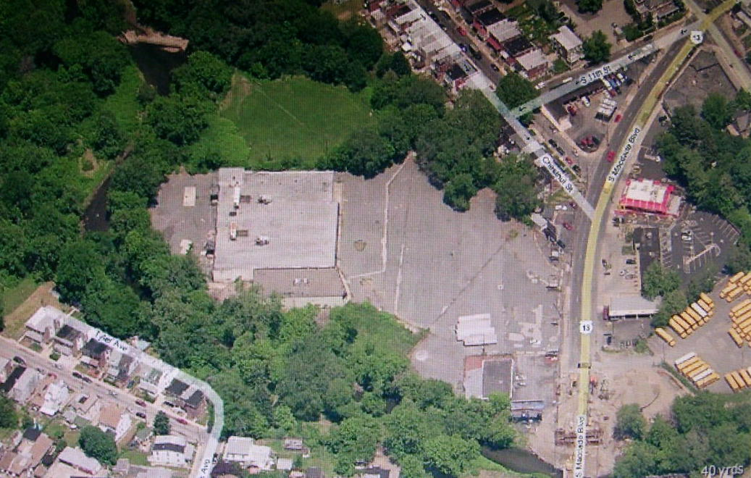

Picture from 1927 before MacDade Blvd showing millrace and Griswold Mill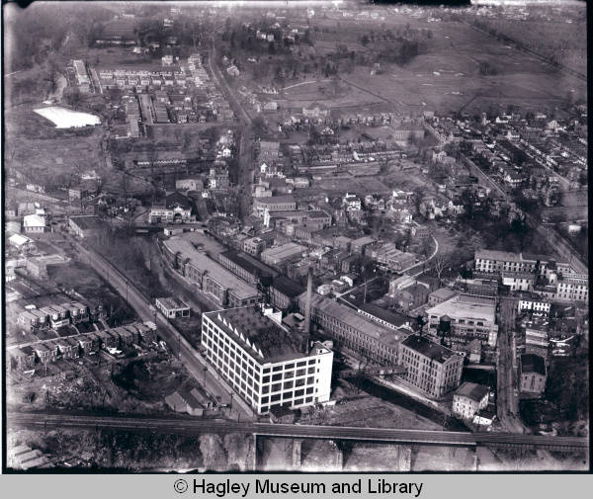
Ashmead's 1884 History of Delaware County http://www.delcohistory.org/ashmead/ashmead_pg518.htm
1695, Joseph Wood, in open court acknowledged a deed for nine acres - the mill tract - to Bethel. The next year, Dec. 8, 1696, John Bethel sold to Samuel Carpenter, the noted merchant of Philadelphia in those early days, a half-interest in several tracts of land, one being nine acres on Darby Creek, "Upon which last-mentioned piece of land there is three water grist-mills and a fulling mill lately erected." In the same deed it is stated that on the same day of the date of the deed to Carpenter, Bethel had purchased from John Blunston "all that millcat race or Trench digged in and through the said Blunston's land and meadow, from the said Darby Creek toward the said mills." This mill-race to-day follows the course "digged" nearly two centuries ago through Blunston's land.

1909 Atlas Map showing (in pencil) MacDade Blvd .